python中查看内存占用的情况
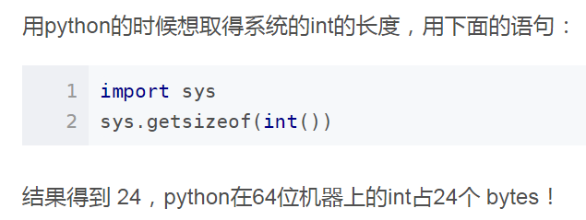
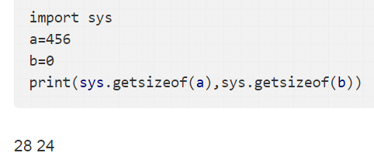

import psutil
import os
info = psutil.virtual_memory()
print ('内存使用：',psutil.Process(os.getpid()).memory_info().rss)
print ('总的内存：',info.total)
print ('内存占比：',info.percent)
print ('内存已用：',info.used)
print ('cpu个数：',psutil.cpu_count())
print ('cpu占比：',psutil.cpu_percent())
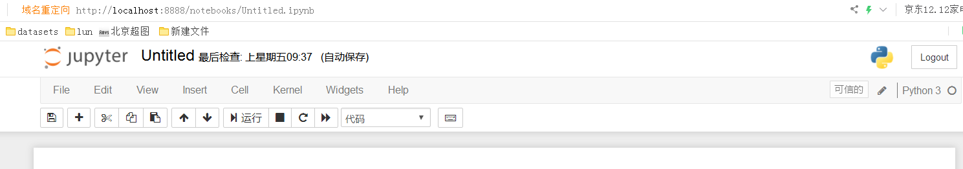
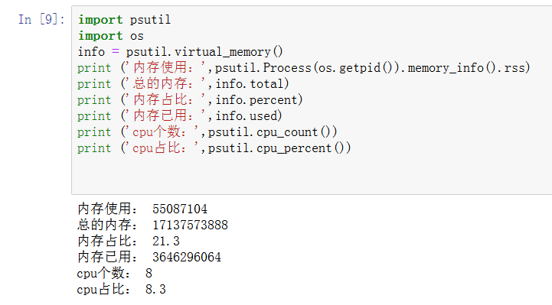
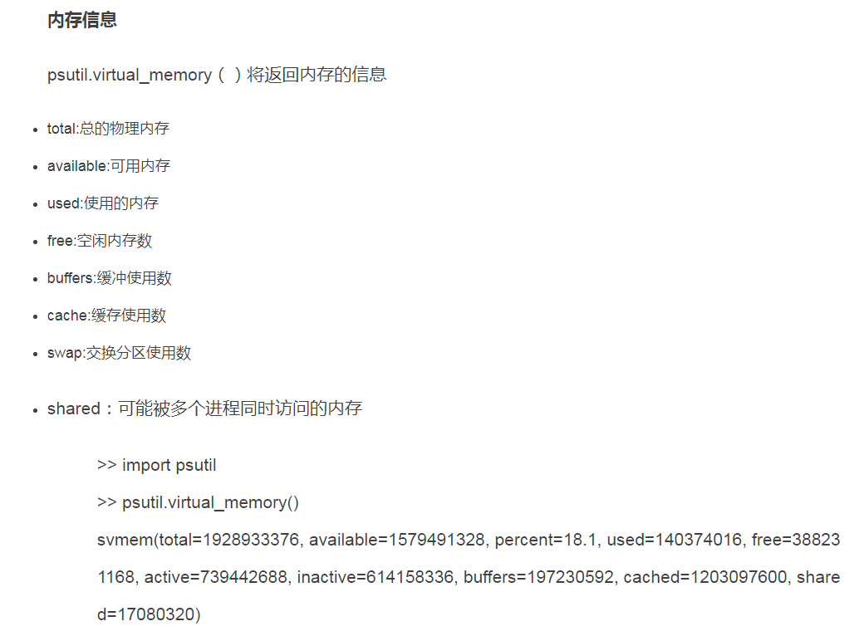

参考：
https://www.jb51.net/article/141838.htm
https://jingyan.baidu.com/album/4ae03de3c235313eff9e6b91.html?picindex=2
https://blog.csdn.net/houyanhua1/article/details/78235751
https://www.cnblogs.com/liu-yao/p/5678157.html

